INSTRUCTIONS:

- ANSWER ANY SIX QUESTIONS. DO NOT ANSWER ALL SEVEN QUESTIONS.
- SOMEOF THE ANSWERS CAN BE TAKEN DIRECTLY FROM THE SOURCES, OTHERS RELY ON OUTSIDE LEARNING.
- MAKE SURE THAT YOUR NAME AND CLASS ARE ON THE COVER OF THE EXAM.

- Question 1: One-word questions
- Question 2: The 13 Colonies
- Question 3: The Declaration of Independence
- Question 4: Paul Revere’s Ride
- Question 5: The War of Independence
- Question 6: Reasons for the Civil War
- Question 7: The Gettysburg Address

- Fill in the missing words. Some might come from the box below. (10)

  - The 13 colonies declared that they were independent in a statement called the ___________________.
  - The Declaration of Independence was mostly written by a Virginia businessman and philosopher called ___________________.
  - Many colonists who did not agree with independence were persuaded by an essay written by ___________________.
  - One of the famous events to spark off the war was the ___________________.
  - When war broke out between the North and the South, ___________________ was appointed to lead the Confederate armies.
  - The leader of the North at that time was ________________________.
  - Lincoln had to change many of his generals, but his two most famous were ___________________ and ___________________.
  - After the war, ___________________ was assassinated at ___________________.

- Study the map of the 13 colonies as a guide to answering the questions that follow. (10)

- Read the following passage from the US Declaration of Independence and then answer the questions which follow. (10)

IN CONGRESS, July 4, 1776.
The unanimous Declaration of the thirteen united States of America,
When in the Course of human events, it becomes necessary for one people to dissolve the political bands which have connected them with another, and to assume among the powers of the earth, the separate and equal station to which the Laws of Nature and of Nature's God entitle them, a decent respect to the opinions of mankind requires that they should declare the causes which impel them to the separation.
We hold these truths to be self-evident, that all men are created equal, that they are endowed by their Creator with certain unalienable Rights, that among these are Life, Liberty and the pursuit of Happiness.—
That to secure these rights, Governments are instituted among Men, deriving their just powers from the consent of the governed, --
That whenever any Form of Government becomes destructive of these ends, it is the Right of the People to alter or to abolish it, and to institute new Government, laying its foundation on such principles and organizing its powers in such form, as to them shall seem most likely to effect their Safety and Happiness. Prudence, indeed, will dictate that Governments long established should not be changed for light and transient causes; and accordingly all experience hath shewn, that mankind are more disposed to suffer, while evils are sufferable, than to right themselves by abolishing the forms to which they are accustomed.
  - What is significant/important about the date of this declaration in the USA today? (2)
___________________________________________________________________
  - What was the “Congress” that is mentioned in the first line? (2)
___________________________________________________________________
___________________________________________________________________
  - According to the second paragraph, all people have certain rights. List these. (3)
- ________________________________________________________________
- ________________________________________________________________
- ________________________________________________________________
  - According to the 4th paragraph, governments should only be changed when absolutely necessary. Why is this? How often did the US decide to change its government? (i.e. hold elections)? (3)
___________________________________________________________________
___________________________________________________________________
___________________________________________________________________
- Study the fragment of a poem written about the War of Independence. (10)

Listen, my children, and you shall hear
Of the midnight ride of Paul Revere,
On the eighteenth of April, in Seventy-Five:
Hardly a man is now alive
Who remembers that famous day and year.

He said to his friend, "If the British march
By land or sea from the town to-night,
Hang a lantern aloft in the belfry-arch
Of the North-Church-tower, as a signal-light,--
One if by land, and two if by sea;
And I on the opposite shore will be,
Ready to ride and spread the alarm
Through every Middlesex village and farm,
For the country-folk to be up and to arm."

Then he said "Good night!" and with muffled oar
Silently rowed to the Charlestown shore,
Just as the moon rose over the bay,
Where swinging wide at her moorings lay
The Somerset, British man-of-war:
A phantom ship, with each mast and spar
Across the moon, like a prison-bar,
And a huge black hulk, that was magnified
By its own reflection in the tide.

  - Explain any 2 of the following phrases: (2)
    - “Spread the alarm”
    - “To be up and to arm”
    - “British man-of-war”
___________________________________________________________________
___________________________________________________________________
  - Why did Paul Revere want to “spread the alarm” in Middlesex? (2)
___________________________________________________________________
___________________________________________________________________
  - Why were the British in Boston that evening? (1)
___________________________________________________________________
___________________________________________________________________
  - List 3 clashes between the British and Americans in Boston around that time? (1)
___________________________________________________________________
___________________________________________________________________
  - Was the poet’s feeling shared by all the citizens of the 13 colonies? (2)
___________________________________________________________________
___________________________________________________________________
  - What was the outcome of Revere’s ride? (2)
___________________________________________________________________
___________________________________________________________________

- Empathy. Imagine that you are a historian writing a section in a text book about the American Revolution. Explain the British and American strengths & weaknesses in the clearest way you can (a paragraph, SWOT analysis, etc.). (10)
______________________________________________________________________________
______________________________________________________________________________
______________________________________________________________________________
______________________________________________________________________________
______________________________________________________________________________
______________________________________________________________________________
_____________________________________________________________________________
______________________________________________________________________________
______________________________________________________________________________
______________________________________________________________________________
______________________________________________________________________________
______________________________________________________________________________
______________________________________________________________________________
______________________________________________________________________________
______________________________________________________________________________
______________________________________________________________________________
______________________________________________________________________________
______________________________________________________________________________
______________________________________________________________________________
______________________________________________________________________________
______________________________________________________________________________

- Complete the following table of the Reasons for the Civil War. (10)

THE NORTH |  | THE SOUTH
Had a diverse economy | however | Depended on farming crops such as __________ and __________.
Had 3 million immigrants from ______________ and _____________ so it didn’t need slaves. | but | Had very few immigrants, so depended on slave labour.
Wanted taxes to be spent on railways and roads. | on the other hand, | ___________________________
Needed tariffs on cheap foreign products so that people would buy US goods. | although | Needed cheap goods so __________________________

Study the photographs below and label them.
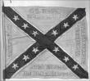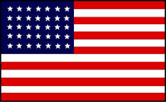
______________________ ______________________
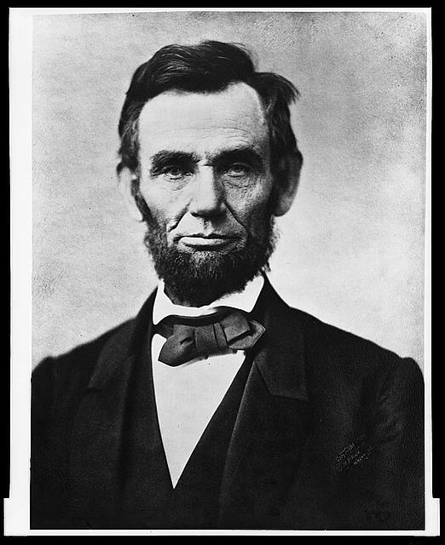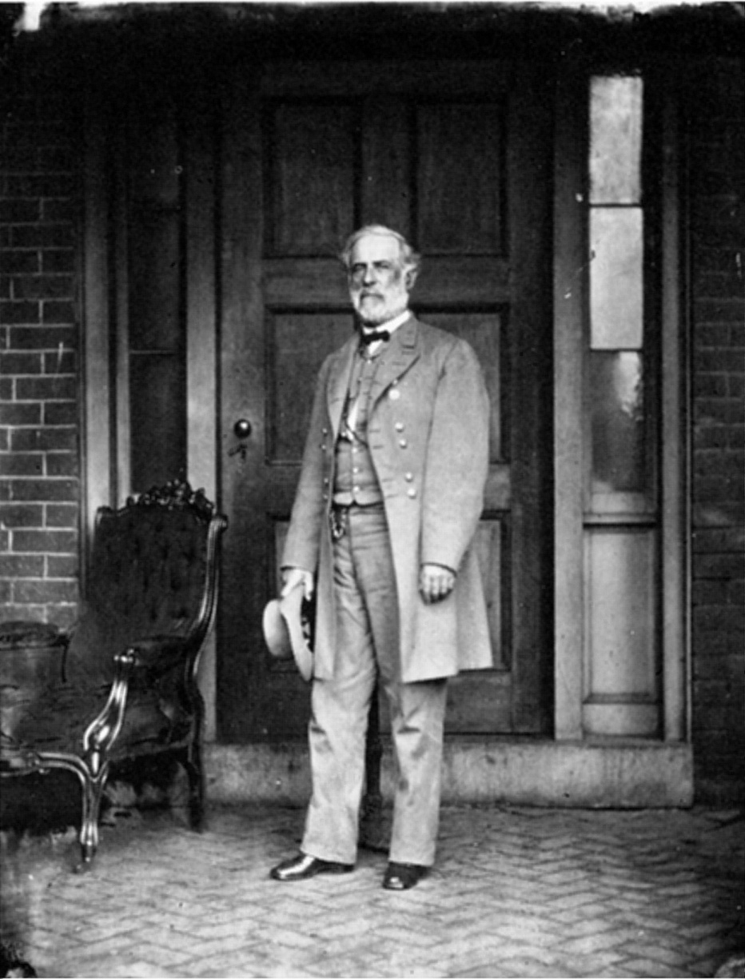
______________________ ______________________

- Study the Gettysburg Address before answering the questions which follow. (10)

  - How many years is “Four score and seven”? (1)
___________________________________________________________________
  - What kind of Liberty do you think Lincoln is talking about? (2)
___________________________________________________________________
___________________________________________________________________
  - According to Lincoln, why is the US fighting the civil war? (2)
___________________________________________________________________
___________________________________________________________________
  - How did people react to the address at first and later? (2)
___________________________________________________________________
___________________________________________________________________
  - Explain how “government of the people, by the people, for the people” is different from other European monarchies? (2)
___________________________________________________________________
___________________________________________________________________

