AL ITTIHAD PRIVATE SCHOOL – AL MAMZAR

2004-2005 History Term III Test
History Time: 90 minutes
Grade 10 Marks: 60

NOTE: Answer ALL questions
This exam consists of SIX pages and a cover page
Please READ the questions and instructions CAREFULLY

SECTION A: The Gilded Age (40 pts)

- Fill in the missing words. Some might come from the box below. (10)
Credit Mobilier Pullman Strike blacklist Progressive
Susan B. Anthony Dumbell Knights of Labor Railroad Strike Elizabeth Cady Stanton Political Machines
Expand Towers Mother Jones Skyscrapers
Gilded Age Haymarket Riot Homestead Strike

  - The name ___________________ suggested a golden appearance but a cheap base.
  - Two people who fought for the right of women to vote were _______________ and ___________________.
  - The ___________________ scandal destroyed the reputation of the US vice-president, Schuyler Colfax.
  - Tall buildings, called _______________ , were first built in Chicago during this period.
  - ___________________ tenements were built to try improve the living conditions of workers.
  - ___________________ provided services for new immigrants and workers.
  - There were many labour strikes, for example, the _______________ .
  - Some workers were placed on a _______________ so they found it very difficult to find work.
  - Education changed to a system called _______________ education.
  - One famous labour organisation that helped US workers during this time was called the _______________ .
- Study the cartoon by Thomas Nast and then answer the questions below. (10)
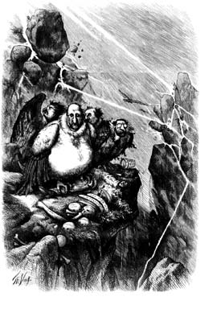

A

A Group of Vultures Waiting for the Storm to “Blow Over” – “Let us prey”

  - Who is the figure labelled A and how do you recognise him? (2)
___________________________________________________________________
___________________________________________________________________
  - Why does Thomas Nast draw these people as vultures? (2)
___________________________________________________________________
___________________________________________________________________
  - What do the bones in the vulture nest tell you about this group of politicians? (2)
___________________________________________________________________
___________________________________________________________________
  - What does the lightning or “Storm” represent? (2)
___________________________________________________________________
___________________________________________________________________
  - Do you think that cartoons in general are accurate enough for us to study in history or not? Explain. (2)
___________________________________________________________________
___________________________________________________________________

- Study the photograph of New York in 1888 or 1889 and then answer the questions which follow. (10)
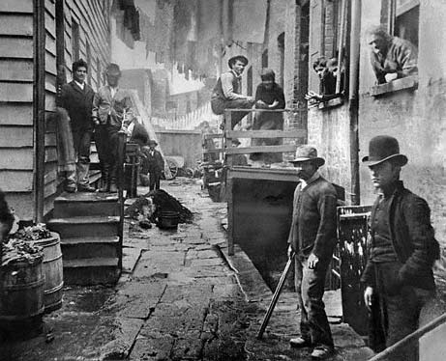
  - What evidence can you find from this picture that living conditions in US cities were bad at this time? (4)
- _________________________________________________________________
- _________________________________________________________________
- _________________________________________________________________
- _________________________________________________________________
  - In your opinion, what caused these conditions: too many immigrant workers or greedy employers? Give a reason for your answer. (2)
___________________________________________________________________
___________________________________________________________________
  - How did technology change the cities? (4)
- _________________________________________________________________
- ________________________________________________________________
- ________________________________________________________________
- _________________________________________________________________

- “Gangs of New York”, scenes from the Film. (10)
  - Do you think the film gave us an accurate picture of city life in the US at that time? Why or why not? Give evidence. (5)
___________________________________________________________________
___________________________________________________________________
___________________________________________________________________
___________________________________________________________________
___________________________________________________________________
___________________________________________________________________

  - How was life in New York City different for the Gilded Class (rich people) and the workers (people in the Five Points). (5)
___________________________________________________________________
___________________________________________________________________
___________________________________________________________________
___________________________________________________________________
___________________________________________________________________
___________________________________________________________________

SECTION B: Map and Graph Skills (20 pts)

- Study the graph about US imports/exports and then answer the questions which follow.

  - What type of graph do we call this? _______________ (2)
  - Which year had the biggest difference of imports and exports?
_______________ (1)
  - How much did the US import in 1910? _______________ (1)
  - How many more imports were there than exports in 1860? _______________ (2)
  - How many more exports were there than imports in 1880? _______________ (2)
  - Why do you think the US was exporting more than importing from 1880 onwards?(2)
___________________________________________________________________

Study the graph about School Enrollment, 1890-1990 and then answer the questions which follow.

  - Both graphs are about _________________. (1)
  - Which graph is being more sensational? _________________ (1)
  - How did Assistant Secretary Roosevelt seem to add to the crisis? (2)
___________________________________________________________________
___________________________________________________________________

