AL ITTIHAD PRIVATE SCHOOL – AL MAMZAR

History Term IV Test
Grade 10 Time: 90 minutes
Marks: 60

- Fill in the missing words. Some might come from the box below. (10)
Roaring 20s race riots labour strikes Model T Charles Lindbergh The Ten Commandments
The Jazz Age Henry Ford Babe Ruth Louis Armstrong
The Flapper Speakeasies Prohibition

  - Other names for the 1920s in the US are ______________________ and ______________________.
  - During this time, the parents were concerned about ______________________ , ______________________ and the red scare.
  - ______________________ built the first electrical power plant.
  - ______________________ introduced assembly line production.
  - Ford’s most famous car was the ______________________ .
  - ______________________ hit a record-breaking 60 home runs in the 1927 season.
  - ______________________ became the first person to fly non-stop across the Atlantic from New York to Paris.
  - Cecille B de Mille produced films like ______________________ .
  - Black musicians like Ella Fitzgerald and ______________________ produced high quality Jazz that was later copied by many musicians and later generations.

- Match the names in column A with their achievements in column B. (5)

A B
Getrude Ederle
Jack Dempsey
Tin Lizzie
F. Scott Fitzgerald
Charlie Chaplin
Defended his boxing title against the French Champion
Nickname of the Model T Ford
Popular silent movie actor
Wrote about the aimlessness and uncertainty in the 20s
Broke the record for swimming the English Channel

- Study the Graph and then answer the questions which follow. (10)

  - What does this graph show? (2)
___________________________________________________________________
___________________________________________________________________
  - How many households had electricity in 1920? ____________ (1)
  - How many households had electricity in 1929? ____________ (1)
___________________________________________________________________
___________________________________________________________________
  - By how much did this increase in the 1920s? _____________ (2)
  - List some of the new 1920s appliances that required electricity. (4)
______________________
______________________
______________________
______________________
______________________

- Study the photograph and then answer the questions which follow. (10)

  - How did the automobile change government spending in the US? (2)
__________________________________________________________________
__________________________________________________________________
  - How did the railway-line villages suffer because of the automobile? (2)
__________________________________________________________________
__________________________________________________________________
  - Name some of the new sights of the 1920s that appeared along the highways? (3)
__________________________________________________________________
__________________________________________________________________
__________________________________________________________________
  - In what ways did the automobile change the city streets and town designs? (3)
__________________________________________________________________
__________________________________________________________________
__________________________________________________________________

- Study the newspaper front page and then answer the questions which follow. (7)
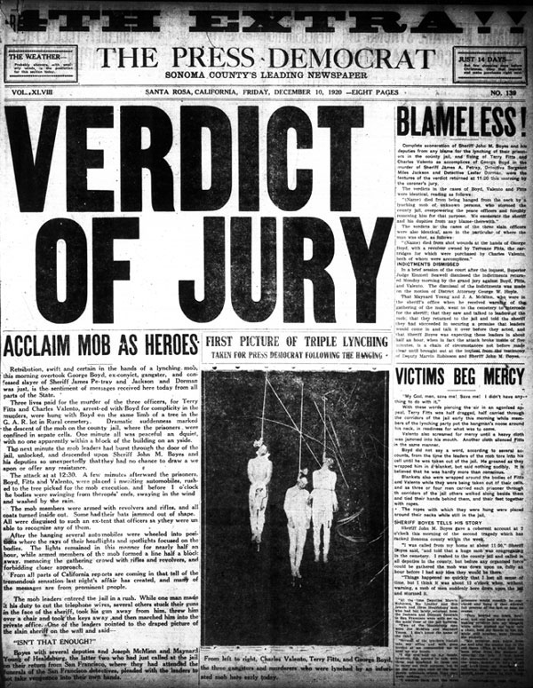
  - What was this new type of newspaper called? ___________________ (1)
  - Name two press associations that supplied the news. (2)
_______________________ ___________________________
  - How did the publishers get readers to buy the newspapers? (2)
__________________________________________________________________
__________________________________________________________________
  - How did these newspapers change US culture? (2)
__________________________________________________________________
__________________________________________________________________

- Study this drawing of a flapper in her automobile and then answer the questions which follow. (10)

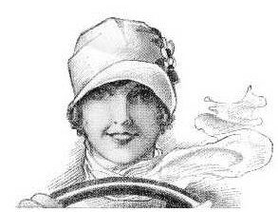

  - What values did the flapper have? (2)
__________________________________________________________________
__________________________________________________________________
  - What values did her parents have? (2)
__________________________________________________________________
__________________________________________________________________
  - Name 3 different race groups that followed the flapper fashion. (3)
___________________
___________________
___________________
  - How did the 1920s technology change women’s lives? (2)
__________________________________________________________________
__________________________________________________________________
  - How did prohibition change people’s lives in the 1920s? (1)
__________________________________________________________________

