AL ITTIHAD PRIVATE SCHOOL – AL MAMZAR

History Term IV Test
Grade 10 Time: 90 minutes
Marks: 60

- Fill in the missing words. Some might come from the box below. (15)
Roaring 20s Tin Lizzie labour strikes Model T Charles Lindbergh Cecille B de Mille
The Jazz Age Henry Ford Babe Ruth Louis Armstrong
The Flapper Jack Dempsey Ella Fitzgerald
Alaska Yellow Tabloid Hawaii Furs Minerals
Phillipines Canada Traders Monroe Roosevelt

  - The US purchased _________________ from Russia in 1867 for about $7 million.
  - Alaska was rich in _________________and _________________.
  - The _________________ Doctrine stated that European powers were not allowed to colonise the Americas in future.
  - American farmers and traders in _________________ overthrew Queen Liliuokalani when she tried to take the vote away from them.
  - US public opinion about Spain was made worse by reporting in the _________________ press.
  - The 1920s re also known as the ______________________ and ______________________.
  - The first person to build an electrical power plant was ________________________.
  - Henry Ford’s most famous 1920s car was the ______________________ .
  - In 1927 _____________________ hit a record number of home runs in the baseball season.
  - The first person to fly non-stop across the Atlantic was ______________________ .
  - Films like “The Ten Commandments” were produced by ______________________ .
  - Black musicians like _______________________and ______________________ produced high quality Jazz that was later copied by many musicians and later generations.

- Study the maps of the Panama Canal and then answer the questions below. (8)

  - Would you choose Panama or Nicaragua to build the Canal? Give reasons for your answer. (2)
___________________________________________________________________
___________________________________________________________________
  - How long is the canal? (Give your answer in kilometers or miles) (2)
___________________________________________________________________
___________________________________________________________________
  - Which is the most difficult section to build? Explain why. (2)
___________________________________________________________________
___________________________________________________________________
  - How did this canal help the US extend its influence in the world? (2)
___________________________________________________________________
___________________________________________________________________
- Study the Electricity Supply Graph to answer the questions which follow. (10)

  - What does this graph show? (2)
___________________________________________________________________
___________________________________________________________________
  - How many households had electricity in 1920? ____________ (1)
  - How many households had electricity in 1929? ____________ (1)
  - What would explain such a large increase in the demand for electricity? (2)
  - List some of the new 1920s appliances that required electricity. (4)
______________________
______________________
______________________
______________________
______________________

- Study the photograph of Henry Ford next to his Model T and then answer the questions which follow. (10)
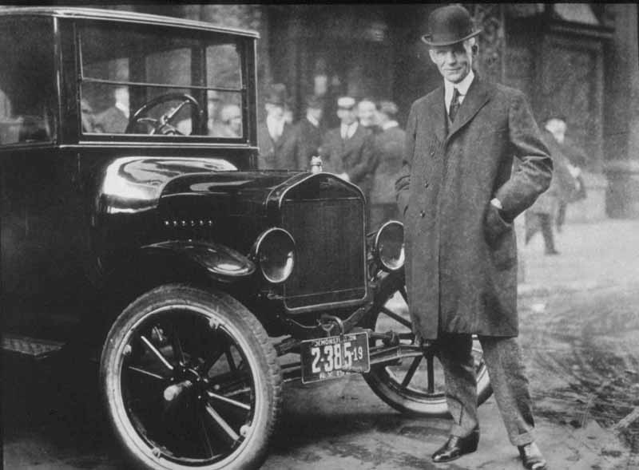

  - How did the automobile change government spending in the US? (2)
__________________________________________________________________
__________________________________________________________________
  - How did the railway-line villages suffer because of the automobile? (2)
__________________________________________________________________
__________________________________________________________________
  - Write some notes about how the automobile changed cities and towns. (6)
- ______________________________________________________________
- ______________________________________________________________
- ______________________________________________________________
- ______________________________________________________________
- ______________________________________________________________
- _____________________________________________________________

- Study the newspaper front page showing a Buffalo Soldier in Cuba and then answer the questions which follow. (7)
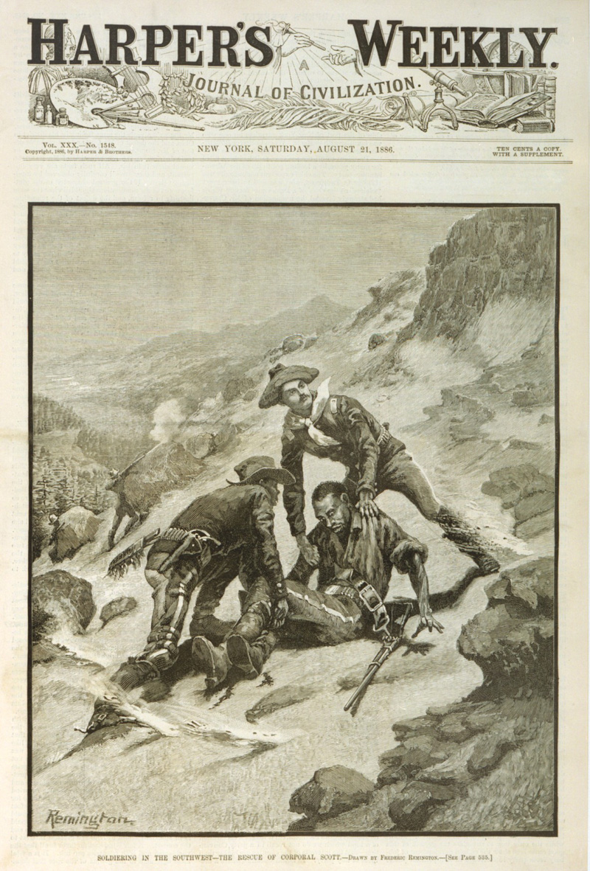
  - Is this a Tabloid or Broadsheet? Explain how publishers got readers to buy the newspaper. (3)
__________________________________________________________________
__________________________________________________________________
__________________________________________________________________
  - What two main press associations or publishers supplied news about the war in Cuba? (2)
_______________________ ___________________________
  - How did these newspapers force the US president to enter the war with Spain? (2)
__________________________________________________________________
__________________________________________________________________
__________________________________________________________________
__________________________________________________________________

- Study this drawing of a flapper in her automobile and then answer the questions which follow. (10)

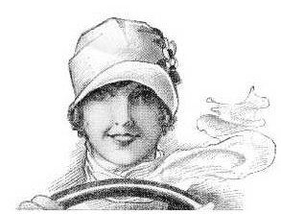

  - Compare and contrast the “Flapper” with her parents and previous generations. (4)
__________________________________________________________________
__________________________________________________________________
__________________________________________________________________
__________________________________________________________________
  - Name any 2 race groups that followed the flapper fashion. (2)
___________________
___________________
  - In your opinion, which 1920s technology change women’s lives most? The car, birth control, or electricity? (3)
__________________________________________________________________
__________________________________________________________________
__________________________________________________________________
__________________________________________________________________
  - How did prohibition change people’s lives in the 1920s? (1)
__________________________________________________________________

