Final Exam Marks: 60

Grade 10 Time: 90 minutes

ANSWER ANY SIX PAGES
N.B. MARKS WILL BE DEDUCTED IF YOU ATTEMPT TO CHEAT BY ANSWERING MORE THAN SIX PAGES.

- Fill in the missing words. Some might come from the box below. (10)
Alaska Monroe Doctrine Admiral Dewey Jose Marti Liluokalani
TS Eliot Ernest Hemingway Georgia O’Keefe

  - The US purchased _________________ from Russia in 1867 for about $7 million.
  - The _________________ _________________ restricted Europeans from American influence and the US from European influence.
  - Queen _________________ was thrown out of Hawaii after she tried to stop some of the traders and planters from voting.
  - Writers like _________________ and ____________________ described the pessimism underlying the Roaring Twenties.
  - Artist _________________ represented the energy and vitality as well as the danger and uncertainty of the Twenties.

Match up the 1920s heroes with their achievements

National Hero | Achievement
Charlie Chaplin  Babe Ruth  Charles Linbergh  Jack Dempsey  Getrude Ederle | Record-holding Baseball Star  Silent Movie Comedian  First woman to swim the Channel  First nationally broadcast sports hero  First solo flight across the Atlantic

- Study the graph and tables as a guide to answering the questions below. (10)

  - What is the source of these statistics and is it a reliable source or not? (2)
___________________________________________________________________
___________________________________________________________________
  - What is the value of US imports and exports in 1860 and 1960? (Be precise!) (2)
1960 Exports _______________ Imports ________________
1860 Exports _______________ Imports ________________
  - During which years did the US export more than it imported? (2)
___________________________________________________________________
___________________________________________________________________
  - Why do you think the US imported more at first? (2)
___________________________________________________________________
___________________________________________________________________
  - Why do you think it imports more now? (2)
___________________________________________________________________
___________________________________________________________________

- Study the map of US Territorial Expansion to 1900. (10)

  - Compare and contrast how and why the US acquired Alaska (1867) with how and why they acquired Hawaii (1989). (5)

ALASKA BOTH HAWAII

  - Why do you think the US business and military leaders wanted a controlling influence in the Philiplines? (3)
___________________________________________________________________
__________________________________________________________________
  - Explain briefly (one sentence) how the US came to control the Islands of Guam and Puerto Rico. (2)
___________________________________________________________________
__________________________________________________________________
- Study the newspaper front page showing a Buffalo Soldier in Cuba and then answer the questions which follow. (7)
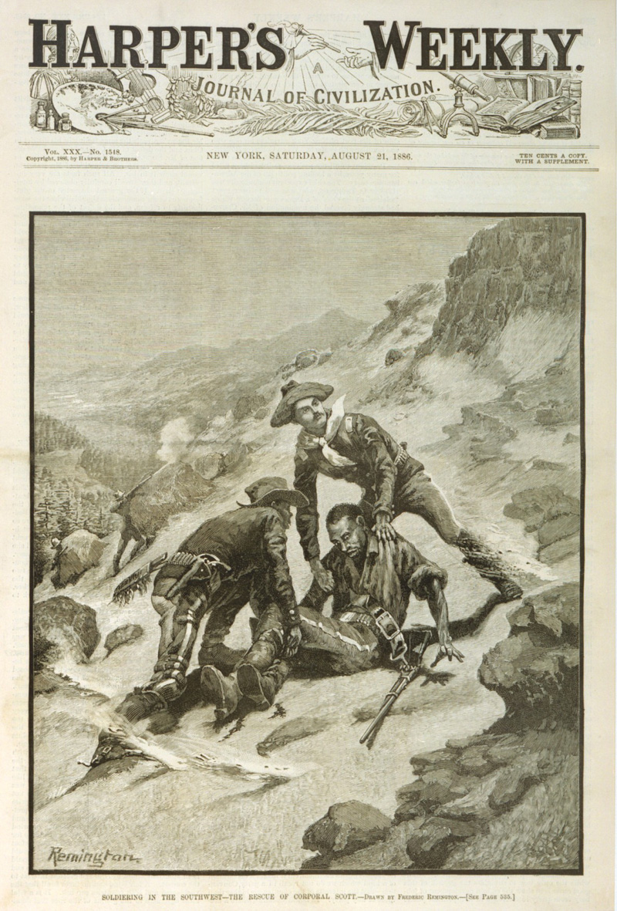
  - Name the two US newspaper publishers responsible for stirring up US readers. (2)
- ______________________________________________________________
- ______________________________________________________________
  - What methods and techniques did they use to stir up their readers? (2)
__________________________________________________________________
__________________________________________________________________
  - President McKinley didn’t want a war with Spain. What two factors forced him into the Spanish-American war? (4)
__________________________________________________________________
__________________________________________________________________
__________________________________________________________________
  - Name any two American heroes that emerged from the war. (2)
- ________________________________
- ________________________________
- Study the photograph of Henry Ford next to his Model T and then answer the questions which follow. (10)
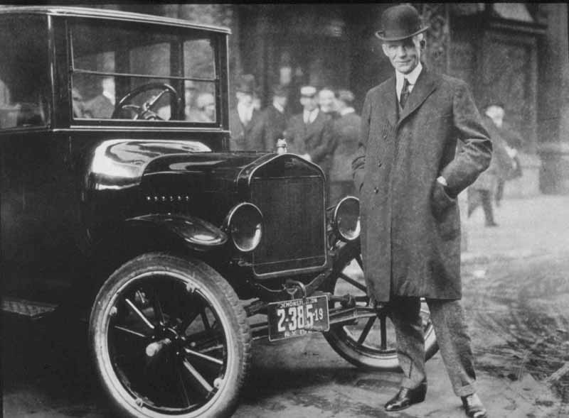

  - Explain why so many people bought the Model T compared to previous cars? (2)
__________________________________________________________________
__________________________________________________________________
  - List 4 ways that the large numbers of cars change cities and villages? (4)
- ______________________________________________________________
- ______________________________________________________________
- ______________________________________________________________
- ______________________________________________________________
  - Describe how the other energy source, electricity, changed US society in the Roaring 20s. Give examples of new electrical products of the 1920s. (3)
__________________________________________________________________
__________________________________________________________________
__________________________________________________________________
__________________________________________________________________

- Study this poem by Langston Hughes and then answer the questions which follow. (10)
I, too, sing America.

I, too, sing America.

I am the darker brother.
They send me to eat in the kitchen
When company comes,
But I laugh,
And eat well,
And grow strong.

Tomorrow,
I'll be at the table
When company comes.
Nobody'll dare
Say to me,
"Eat in the kitchen,"
Then.

Besides,
They'll see how beautiful I am
And be ashamed--

I, too, am America.

Langston Hughes

  - Describe the attitude of the Haarlem Renaissance writers to American race relations. (3)
__________________________________________________________________
__________________________________________________________________
__________________________________________________________________
  - Describe their attitude to other African Americans. (2)
__________________________________________________________________
  - Name a African American musical style that became associated with the Haarlem Renaissance and the 1920s. (2)
__________________________________________________________________
  - Name any 3 of the famous musicians of the 1920s. (1)
__________________________________________________________________

- Study these photographs of flappers and the older generation as a guide to answering the questions which follow. (10)
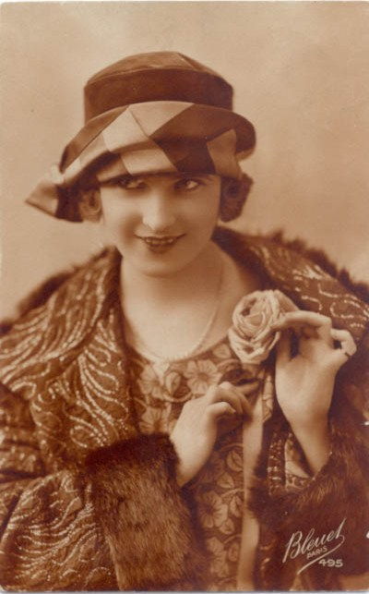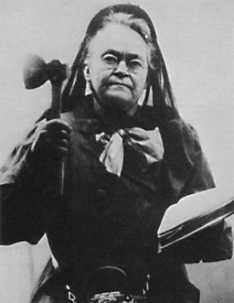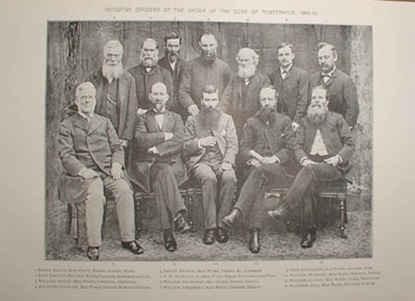
  - Compare and contrast the behaviour and values of the flappers with the behaviour values of their parents. (6)

Flapper Both Parents

  - How did the 1920s technology change women’s lives? (2)
__________________________________________________________________
__________________________________________________________________
  - How did prohibition change people’s lives in the 1920s? (2)
__________________________________________________________________
__________________________________________________________________

