AL ITTIHAD PRIVATE SCHOOL – AL MAMZAR

History Term I Test
Grade 11 Time: 90 minutes
Marks: 60

- Fill in the missing words. Some might come from the box below. (10)
Alliance Splendid Isolation Plan 17 Schlieffen Plan Alsace Lorraine dreadnought “over the top” Lusitania Zeppelin Entente Princip

  - Germany, Austro-Hungary, and Italy formed the Triple _______________.
  - Britain, France and Russia formed the Triple _______________.
  - France felt resentful over losing the region of _______________ _______________ to Germany.
  - Britain felt it was in “splendid isolation” but still developed the _______________ battleships to fight the growing German navy.
  - Germany developed a plan called the _______________ _______________ to prepare for a war with France and Russia, and France prepared _______________ _______________ to prepare for a war with Germany.
  - Germany used huge hydrogen balloons called _______________ to drop bombs on enemy cities.
  - War was finally declared after _______________ murdered Archduke Franz Ferdinand and his wife Sophie in Sarajevo.
  - The USA finally entered the war after its passenger ship, the _______________ was sunk by German u-boats.
  - Most of the casualties in WWI occurred in the trenches when soldiers had to go _______________.

- Photographs and Cartoons.
  - Identify the following people in the photographs. (8)

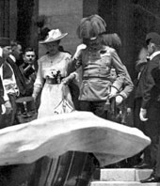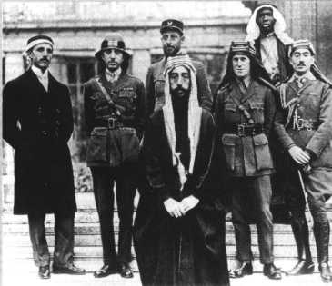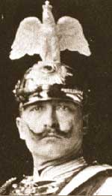

___________________________ _____________________________ _______________
b) Who are the 3 people in the cartoon, and what does the cartoonist want us to think about them? (5)
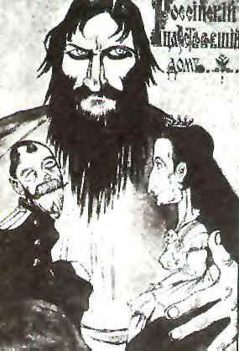

_______________ _______________ _______________.

__________________________________________________________________
___________________________________________________________________
- Study the two descriptions of air warfare. The answers come from outside the passage as well. (10)

A: Two machines jump up before me. A couple of shots. Gun jammed. I feel defenceless and in my rage try to ram an enemy’s machine. The guns begin to fire again. I see the observer and pilot lurch forward. Their plane crashes in a shellhole. The other Englishman vanishes.

B: We had a pretty horrifying time with the Zepps again last night. We were woken at 10:30 by a terrific noise of bombs, aircraft, guns, etc. apparently all around us; we rushed on dressing gowns, said a prayer and got downstairs as quickly as we could, the lights were put out just as we got to the bottom.

  - The pilot describes a dogfight between two aeroplanes in extract A. What else were the planes used for in WWI? (3)
___________________________________________________________________
___________________________________________________________________
___________________________________________________________________
  - How were the planes improved during the war? (2)
___________________________________________________________________
___________________________________________________________________
  - Who was the most famous World War I pilot – Hint- He was German and flew a red plane. (1)
___________________________________________________________________
  - What were the “Zepps” (Zeppelins or airships) used for? (2)
___________________________________________________________________
___________________________________________________________________
  - What major disadvantages did the Zepps have? (2)
___________________________________________________________________
___________________________________________________________________

- Study the aerial photograph of the trenches and then answer the questions which follow. (10)

  - Label the following features: (3)
front-line trenches _____________________
support trenches _____________________
no-man’s land _____________________
  - Explain why you think the trenches had zig-zag lines, not straight lines. (2)
___________________________________________________________________
___________________________________________________________________
  - What effect do you think the trench systems had on horse-mounted war? (1)
___________________________________________________________________
  - What tactic was most often used to capture the enemy trenches? (1)
___________________________________________________________________
  - How would you attack the enemy trenches in 1918? (2)
___________________________________________________________________
___________________________________________________________________
___________________________________________________________________
  - What effect did the tank have on trench warfare? (1)
___________________________________________________________________
___________________________________________________________________
- Compare the painting by a famous artist (John Singer Sargent) and the poem by Wilfred Owen. (6)

…
In all my dreams, before my helpless sight,
He plunges at me, guttering, choking, drowning.
If in some smothering dreams you too could pace
Behind the wagon that we flung him in,
And watch the white eyes writhing in his face,
… Dulce et decorum est

- What method of war are is being described in both of these sources? (1)
___________________________________________________________________
- What types of gas were used? (2)
___________________________________________________________________
- What was the main point of gas attacks? (1)
___________________________________________________________________
- Why do you think gas attacks were regarded with such fear? (2)
___________________________________________________________________
___________________________________________________________________

- Choose ONE of the following statements:

The war at sea was more important than the Western Front.
Germany was to blame for the war.

Do you agree or disagree with the statement? Explain, using evidence. (4)
___________________________________________________________________
___________________________________________________________________
___________________________________________________________________
___________________________________________________________________
___________________________________________________________________

- Imagine that you are a soldier fighting in one of the trenches of The Somme, Gallipoli, or Verdun. Write a letter home explaining what the situation is like, what you think about your decision to fight and what you hope for the near future. (10)
___________________________________________________________________
___________________________________________________________________
___________________________________________________________________
___________________________________________________________________
___________________________________________________________________
___________________________________________________________________
___________________________________________________________________
___________________________________________________________________
___________________________________________________________________
___________________________________________________________________
___________________________________________________________________
___________________________________________________________________
___________________________________________________________________
___________________________________________________________________
___________________________________________________________________

