AL ITTIHAD PRIVATE SCHOOL – AL MAMZAR

History Term I Test
Grade 11 Time: 60 minutes
Marks: 40

- Fill in the missing words. Some might come from the box below. (10)
Alliance Splendid Isolation Plan 17 Schlieffen Plan Alsace Lorraine dreadnought “over the top” Lusitania Zeppelin Entente Princip

  - Germany, Austro-Hungary, and Italy formed the Triple _______________.
  - Britain, France and Russia formed the Triple _______________.
  - France felt resentful over losing the region of _______________ _______________ to Germany.
  - Britain felt it was in “splendid isolation” but still developed the _______________ battleships to fight the growing German navy.
  - Germany developed a plan called the _______________ _______________ to prepare for a war with France and Russia, and France prepared _______________ _______________ to prepare for a war with Germany.
  - Germany used huge hydrogen balloons called _______________ to drop bombs on enemy cities.
  - War was finally declared after _______________ murdered Archduke Franz Ferdinand and his wife Sophie in Sarajevo.
  - The USA finally entered the war after its passenger ship, the _______________ was sunk by German u-boats.
  - Most of the casualties in WWI occurred in the trenches when soldiers had to go _______________.

- Photographs and Cartoons.
  - Identify any five people in the following photographs. (5)

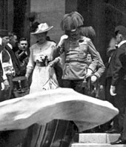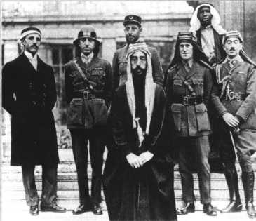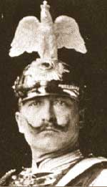

___________________________ _____________________________ _______________

b) Who are the people in this cartoon. What message is the cartoonist giving us about them? (5)
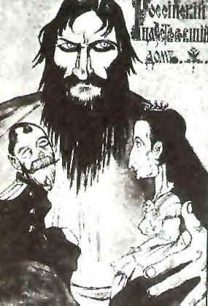

_______________ _______________ _______________.

__________________________________________________________________
___________________________________________________________________
- Study the two descriptions of air warfare. The answers come from outside the passage as well. (5)
A: Two machines jump up before me. A couple of shots. Gun jammed. I feel defenceless and in my rage try to ram an enemy’s machine. The guns begin to fire again. I see the observer and pilot lurch forward. Their plane crashes in a shellhole. The other Englishman vanishes.

B: We had a pretty horrifying time with the Zepps again last night. We were woken at 10:30 by a terrific noise of bombs, aircraft, guns, etc. apparently all around us; we rushed on dressing gowns, said a prayer and got downstairs as quickly as we could, the lights were put out just as we got to the bottom.
  - In A, the pilot describes a fight between two aeroplanes. What can you discover here about the quality of planes in WWI? (1)
___________________________________________________________________
  - Who was the most famous World War I pilot – Hint- He was German and flew a red plane. (1)
___________________________________________________________________
  - Passage B describes an attack by Zeppelins. What were the Zeppelins used for in WWI? (2)
___________________________________________________________________
___________________________________________________________________
  - Why do you think the lights in the house were turned off? (1)
___________________________________________________________________

- Study the description of a WWI gas attack from a poem by Wilfred Owen. (5)
…
In all my dreams, before my helpless sight,
He plunges at me, guttering, choking, drowning.

If in some smothering dreams you too could pace
Behind the wagon that we flung him in,
And watch the white eyes writhing in his face,
…

- What gas was used in these attacks? (1)
___________________________________________________________________
- Why did armies use gas to attack their enemies? (2)
___________________________________________________________________
- Why do you think soldiers were so afraid of gas attacks? (2)
___________________________________________________________________
___________________________________________________________________

- Study the aerial photograph of the trenches and then answer the questions which follow. (10)

  - Name the features labelled A, B and C: (3)
A _______________, B ________________, C __________________
  - Explain why you think the trenches had zig-zag lines, not straight lines. (2)
___________________________________________________________________
___________________________________________________________________
  - Imagine that you are a soldier living in the trenches. Write a letter home to describe the living conditions in the trenches. Mention any 5 features of life there. (5)
___________________________________________________________________
___________________________________________________________________
___________________________________________________________________
___________________________________________________________________
___________________________________________________________________
___________________________________________________________________
___________________________________________________________________

