History Term II Test
Grade 11 Time: 90 minutes
Marks: 60

- Fill in the missing words. Some might come from the box below. (10)
£6 600 million League of Nations Georges Clemenceau Woodrow Wilson David Lloyd-George peasant
aristocracy capitalists Father Gapon Rasputin

  - Germany was forced to pay _______________ as reparations to the Allies.
  - France was represented at the Treaty of Versailles by _______________.
  - Britain was represented by _______________.
  - The USA was represented by _______________.
  - After WWI, the _______________ was established to keep the world at peace.
  - In Russia, most of the population were _______________ who lived in communes.
  - The _______________ consisted on 1.5 % of the population but owned 25% of the land.
  - In the cities, a growing group of people called _______________ were unhappy about the social conditions.
  - In 1905, _______________ led a group of demonstrators to the Tsar’s Winter Palace in St. Petersburg.
  - Tsar Nicholas and the Tsarina Alexandra took advice from a renegade priest called __________________.
- Photographs and Cartoons. (10)
  - Identify the following people in the photographs. (6)
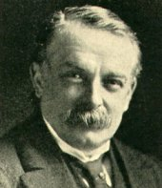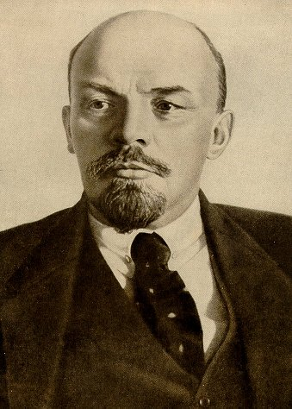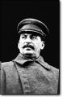

________________________ ____________________ _______________
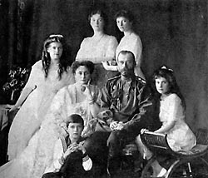
b) Who are the people in the photograph? What happened to them in 1917? (4)
__________________________________________________________________
___________________________________________________________________
__________________________________________________________________
___________________________________________________________________

- Study the map of Germany after World War I. Write notes about how the Treaty of Versailles “punished” Germany for its role in WWI. Use the headings. (10)

  - War Guilt (1)
- _________________________________________________________________
  - Reparations (1)
- _________________________________________________________________
  - Territories (land in Europe) and Colonies (land overseas). (4)
- _________________________________________________________________
- ________________________________________________________________
- ________________________________________________________________
- ________________________________________________________________
  - Armed Forces (2)
- _________________________________________________________________
- _________________________________________________________________
  - Do you think the Treaty was fair or not? (2)
___________________________________________________________________
___________________________________________________________________

- Study the following painting of the 1905 shooting outside the Tsar’s Winter Palace. (10)

  - Imagine you are one of the crowd. Explain why you are there, what happened, and what you think of the events. (5)
___________________________________________________________________
___________________________________________________________________
___________________________________________________________________
___________________________________________________________________
___________________________________________________________________
___________________________________________________________________
  - Imagine you are one of the soldiers. Explain why you are there, what happened, and what you think of the events. (5)
___________________________________________________________________
___________________________________________________________________
___________________________________________________________________
___________________________________________________________________
___________________________________________________________________
___________________________________________________________________

- Study the following graphs and statistics as a guide to answering the questions which follow. (10)

  - What percentage (%) of the soldiers who were mobilised (went to war) were casualties (injured or died)? _____________________ (2)
  - What was the price of a bag of flour in 1914 ________ & 1917 ________ (2)
  - What was the price of a bag of potatoes in 1914 ________ & 1917 ________ (2)
  - What effect did the course of the war have on the number of peasant strikes and uprisings? (1)
___________________________________________________________________
  - Do you think the Tsar was weak? Explain (2)
___________________________________________________________________
___________________________________________________________________
___________________________________________________________________

- Study the graph of Bolshevik party support. (10)

- What 2 major events occurred in March 1917? (1)
___________________________________________________________________
- How could these two events help the Bolsheviks increase their support? (2)
___________________________________________________________________
- What methods did Lenin use to seize (take) power? (4)
___________________________________________________________________
- What mistakes did Kerenksy make to help Lenin take over? (3)
___________________________________________________________________
___________________________________________________________________

