AL ITTIHAD PRIVATE SCHOOL – AL MAMZAR

History Term III Test
Grade 11 Time: 90 minutes
Marks: 60

Answer any SIX sections

Marks will be deducted if you answer more than six!

- Fill in the missing words. Some might come from the box below. (10)
Mein Kampf Sudetenland Pearl Harbor U-boats Stalingrad Spanish Appeasement Russia
Blitzkrieg Das Kapital France Rhineland
99.75% 96.25% Saar

  - Hitler outlined his plans for Germany in a book called _______________ .
  - In 1935, Hitler took back the rich _______________ region to supply factories and build German industries.
  - During the _______________ Civil War, Hitler tested out his troops and planes on cities like Guernica.
  - Neville Chamberlain developed a policy of _______________ when dealing with Hitler.
  - In 1938, _______________ of Austrian’s declared they wanted “Anschluss” with Germany.
  - In 1938, Hitler annexed the _______________ part of Czechoslovakia to include it with Germany.
  - In 1939, Hitler made a pact with _______________ whereby the two countries agreed not to attack each other.
  - On Sunday, 7th December 1941, the Japanese attacked _______________ _______________, a US naval base in the Pacific Ocean.
  - Hitler used a type of war called _______________ or “lightning war” to overrun most of Europe in 1939.
  - During the Battle of the Atlantic, German _______________ almost cut off food and oil supplies to Britain.
- Who are the following people? Also state which country they came from or which side they were on. (10)
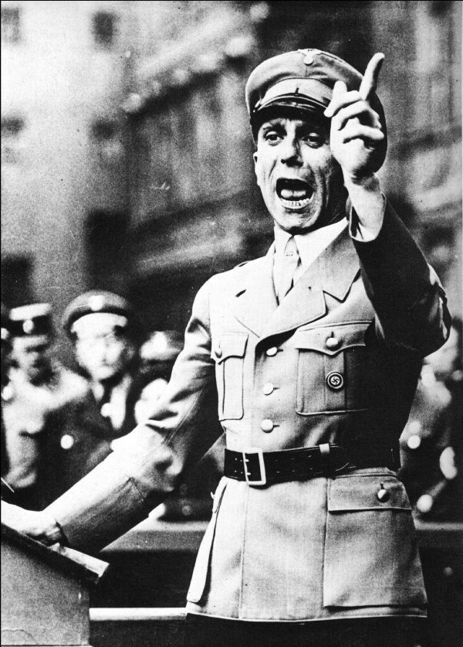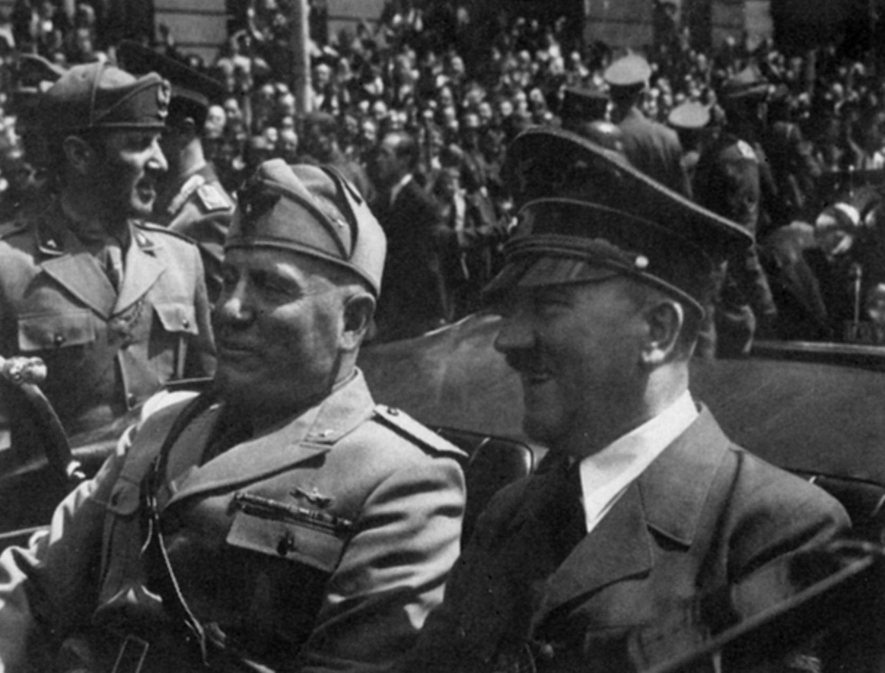
_______________ _______________ _______________
_______________ _______________ _______________
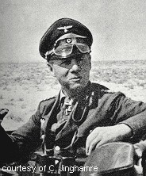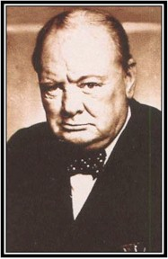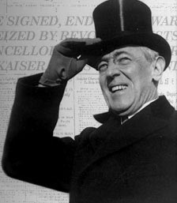
_______________ _______________ _______________
_______________ _______________ _______________
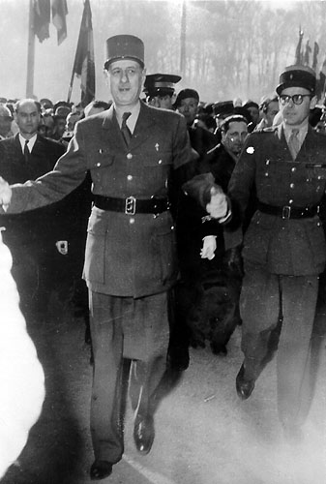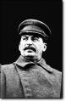
_______________ _______________
_______________ _______________

- Study the photograph and then answer the questions which follow. (6)
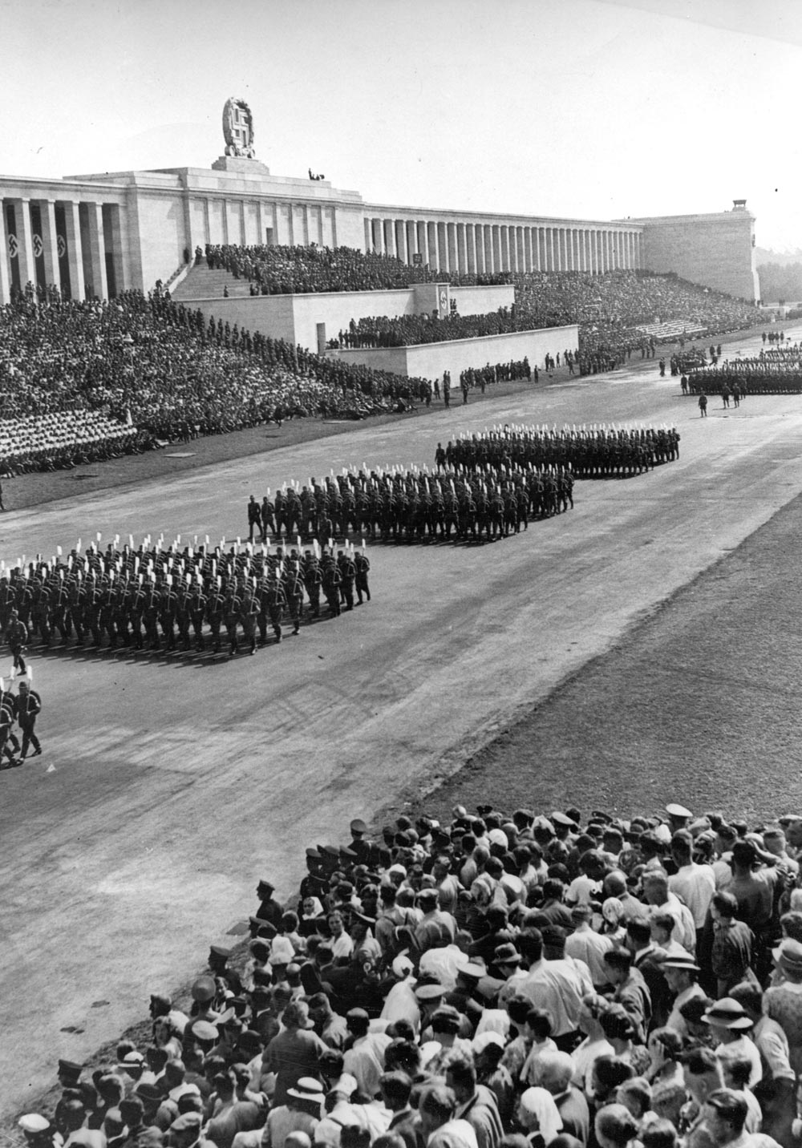

  - List Hitler’s plans for the German nation as set out in his book, Mein Kampf? (3)
- _________________________________________________________________
- _________________________________________________________________
- _________________________________________________________________
  - If you were a Hitler supporter, what would this parade make you think about the Nazis? (2)
___________________________________________________________________
___________________________________________________________________
  - If you were a critic of Hitler, what would this parade make you think about him? (2)
___________________________________________________________________
___________________________________________________________________
  - Why did the League of Nations fail to stop Hitler? (3)
__________________________________________________________________
___________________________________________________________________

- Study the cartoon and then answer the questions below. (10)
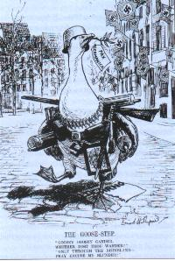
The caption underneath reads:
The Goose-step: / “Goosey Goosey Gander, / whither dost thou wander?”/
“Only into the Rhineland, / Pray excuse my blunder”

  - How can you tell that the goose is supposed to be a German soldier? (2)
___________________________________________________________________
___________________________________________________________________
  - Study the Goose carefully. What does the cartoonist think about Nazi Germany or the Nazi army? (2)
___________________________________________________________________
___________________________________________________________________
  - What part of the Treaty of Versailles is the goose “blundering over” (breaking)? (2)
___________________________________________________________________
___________________________________________________________________
  - Why is the German entering the Rhineland with so much military equipment? (2)
___________________________________________________________________
___________________________________________________________________
  - Do you think it was accurate to portray the Nazis (Hitler’s army) as Geese? Why or why not? (2)
___________________________________________________________________
___________________________________________________________________
- Study the following graph. (5)
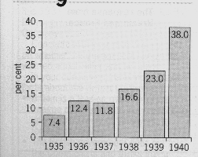
The proportion (%) of German spending that went into armaments, 1935-1940.
  - What percentage (%) of German spending went into armaments in 1935 and 1939? (2)
1935 _________________ 1939 __________________
  - Why do you think there was such a drastic (sudden and large) increase in armaments spending in 1940? (1)
___________________________________________________________________
___________________________________________________________________
  - What does this graph tell you about life in Europe during 1935 to 1939. (2)
___________________________________________________________________
___________________________________________________________________
Study the map and then answer the questions which follow. (5)

  - Label the areas marked (i) to (v).
- _____________________ ii) _____________________
iii) _____________________ iv) _____________________
v) _____________________
- Study this newspaper photograph taken after the Munich Agreement between European leaders and Hitler. (10)
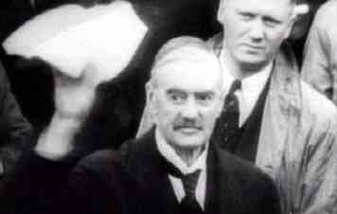
  - Who is the man holding the treaty? (1)
___________________________________________________________________
  - What does the treaty do to the Sudetenland and what did it promise for the rest of Europe? (2)
___________________________________________________________________
___________________________________________________________________
  - What forced Chamberlain to sign this Munich Agreement with Hitler? (3)
___________________________________________________________________
___________________________________________________________________
___________________________________________________________________
  - Do you think his policy of “Appeasement” was a wise or foolish decision? Think about all the events leading to World War II. (4)
___________________________________________________________________
___________________________________________________________________
___________________________________________________________________
___________________________________________________________________
- Study the photograph of the attack on Pearl Harbour. (10)
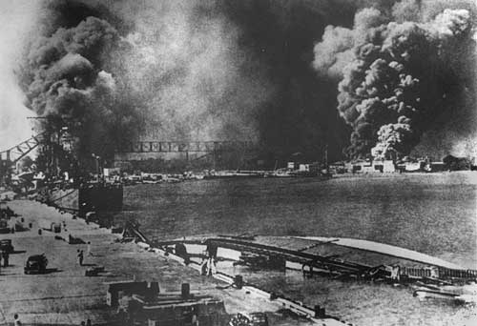
  - How did the Japanese and US increase tension in the Pacific area? Use the following words in your answer (Manchuria, trade rivalry, raw materials) (3)
- _________________________________________________________________
- _________________________________________________________________
- _________________________________________________________________
  - What was the Lend-Lease scheme? Did this show that the US had already taken sides in the war? (2)
___________________________________________________________________
___________________________________________________________________
___________________________________________________________________
  - Which three countries signed the Axis or Tri-nations agreement? (3)
- _____________________
- _____________________
- _____________________
  - What did Japan do to try to knock the US out of the Pacific? Why did they attack on a Sunday? (2)
___________________________________________________________________
___________________________________________________________________

- Complete this table. Why did Britain win the Battle of Britain? (5)

FACTOR | HOW IT LED TO AN ALLIED VICTORY
Technology

Weapons

Tactics

Leadership

- Short paragraph. How did Stalin turn the early Russian defeats into a graveyard for the German army. (5)
___________________________________________________________________
___________________________________________________________________
___________________________________________________________________
___________________________________________________________________
___________________________________________________________________
___________________________________________________________________
___________________________________________________________________
___________________________________________________________________
___________________________________________________________________
___________________________________________________________________
___________________________________________________________________
___________________________________________________________________
___________________________________________________________________
___________________________________________________________________
___________________________________________________________________
___________________________________________________________________
___________________________________________________________________

