AL ITTIHAD PRIVATE SCHOOL – AL MAMZAR

History Term IV Test
Grade 11 Time: 90 minutes
Marks: 60

Answer any SIX sections

Marks will be deducted if you answer more than six!

- Fill in the missing words. Some might come from the box below. (10)
Barbarossa Dachau Stalingrad Prague Arthur Harris Von Paulus Kursk
Hiroshima Bergen-Belsen Erwin Rommel Leningrad Nagasaki Treblinka

  - Hitler’s invasion of Russia was called Operation ______________________.
  - By 1942, the German army had reached the 3 important cities of Moscow, ______________________, and ______________________.
  - The German tanks army was defeated at ______________________ and ______________________ surrendered at Stalingrad.
  - The head of the RAF bombing raids on Germany was Sir ______________________.
  - The first Atomic bomb was dropped on ______________________ and the second on ______________________.
  - Civilian prisoners were forced to work, tortured and killed in concentration camps at Buchenwald, ______________________ and ______________________.

- Study the quotations about the Bombing of Europe and then answer the questions which follow. (10)
We found this petrol station. It was situated in the middle of the flattened area, but the whole workforce that belonged to it lay dead. We saw thousands of dead bodies, not hundreds, but thousands. Some lay in great piles and I took some film and some photographs of these bodies, but I had to stop. I just couldn’t take it all in. It was mainly women and children who had been killed in the firestorm, just lying there.
Hans Brunswig, firefighter in Hamburg, Germany, in 1943.
Bombing forced Germany to divide the economy between too many competing claims … In the air over Germany, or on the fronts in Russia and France, German forces lacked the weapons to finish the job. German forces were denied approximately half their battle front weapons and equipment in 1944. it is difficult not to regard this margin as decisive.
British Historian, Richard Overy, in 1996

a) What problems did the bombers face when they were bombing a city from the air? (3)
_______________________________________________________________________
_______________________________________________________________________
_______________________________________________________________________
- Why did Sir Arthur Harris decide to start the bombing raids on Germany? (3)
_______________________________________________________________________
_______________________________________________________________________
_______________________________________________________________________
- Do you think the bombing was justified or not? Explain. (4)
_______________________________________________________________________
_______________________________________________________________________
_______________________________________________________________________
_______________________________________________________________________
_______________________________________________________________________
_______________________________________________________________________

- Study the photograph of the Atomic Bomb dropped on Hiroshima and then answer the questions which follow. (10)
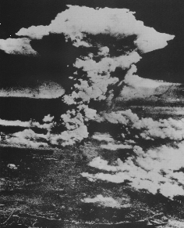

  - ______________________ was the president who authorised using the bomb. (1)
  - The __________________________________ was the team of scientists who created the bombs. (1)
  - Describe some of the effects of the atomic bomb. (2)
__________________________________________________________________
__________________________________________________________________
  - If you were president of the US at that time, would you use the bomb or not? Explain fully. You can agree and disagree. (6)
__________________________________________________________________
__________________________________________________________________
__________________________________________________________________
__________________________________________________________________
__________________________________________________________________
__________________________________________________________________
__________________________________________________________________

- Study the photograph taken from the Battle of Stalingrad and then answer the questions which follow. (10)
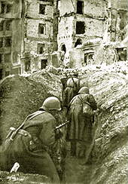
  - Describe the initial successes of Hitlers Blitzkrieg against Russia in June 1941. (3)
- ______________________________________________________________
- ______________________________________________________________
- ______________________________________________________________
  - Explain how the Russians reacted to the invasion. (2)
__________________________________________________________________
__________________________________________________________________
__________________________________________________________________
  - What possible reasons could Hitler have had for attacking his former ally, Stalin? (2)
__________________________________________________________________
__________________________________________________________________
  - How was Hitler partly responsible for his own defeat in Stalingrad and Russia? (2)

__________________________________________________________________
__________________________________________________________________
__________________________________________________________________

- Study the two sources about concentration camps and then answer the questions which follow. (10)
We were captured and forced down the mines … The Japanese did not treat the workers like human beings, but like animals. “Exchange coal with Chinese people’s lives” was their slogan. “‘There are so many Chinese … when you kill one there are always more.” The workers had to drink the stinking water at the bottom of the coal pit. When people became seriously ill they tied there legs and arms, carried them and kicked them into this hole. Dogs were waiting down there, biting and tearing the bodies to pieces.
A Chinese miner remembers his experience of Japanese occupation.

  - Why did the Japanese force these Chinese people into concentration camps? (2)
___________________________________________________________________
___________________________________________________________________
  - Using the description of the Japanese camp given above, and your knowledge gained from class assignments, compare and contrast the Japanese and German camps. (4)
___________________________________________________________________
___________________________________________________________________
___________________________________________________________________
___________________________________________________________________
__________________________________________________________________
___________________________________________________________________
  - List some of the groups of people put into the German camps. (4)
- ______________________________________________________________
- ______________________________________________________________
- _____________________________________________________________
- _____________________________________________________________

- Study the World War II poster and then answer the questions which follow. (10)
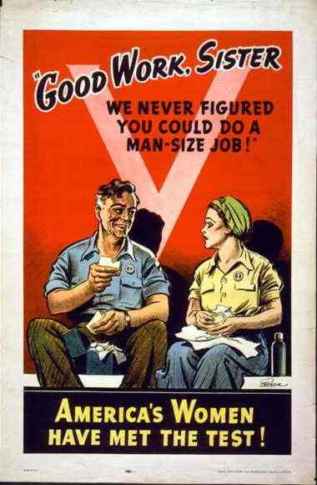

  - While men went to fight, what kinds of jobs did women do? (3)

___________________________________________________________________
___________________________________________________________________
  - How did the propaganda agent show that men appreciated women in this poster?(3)

___________________________________________________________________
___________________________________________________________________
___________________________________________________________________
  - How did the war help change attitudes towards women? (2)

___________________________________________________________________
___________________________________________________________________
  - If you were the propaganda agent, what kind of name would you give to this woman or the two workers? (2)
___________________________________________________________________
___________________________________________________________________
- Study the propaganda poster and then answer the questions which follow. (10)
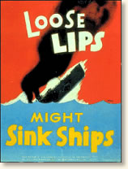

  - What propaganda message is this poster getting across? (2)
___________________________________________________________________
___________________________________________________________________
  - Do you think the poster is effective or not? Explain. (2)
___________________________________________________________________
___________________________________________________________________
  - What is the point of war-time propaganda? (3)
___________________________________________________________________
___________________________________________________________________
___________________________________________________________________
  - What other forms of information were controlled? (3)
___________________________________________________________________
___________________________________________________________________
___________________________________________________________________

