History Term I Test
Grade 12 Time: 60 minutes
Marks: 40

- Complete the summary table of events from the “Big 3” meetings at EITHER Yalta OR Potsdam. (10)
 | Yalta | Potsdam
Who were the leaders?
What to do with Germany & Berlin.
What to do with the Nazis.
What to do with other European countries.
How to behave to each other.

- Study the quotation and then answer ANY 5 questions which follow. (10)

West Berlin … has many roles. It is more than a showcase of liberty, an island of freedom in a Communist sea. It is more than a link with the free world, a beacon of hope behind the iron curtain, an escape hatch for refugees. Above all, it has become the resting place of Western courage and will … We cannot and will not permit the Communists to drive us out of Berlin.
John F. Kennedy (before he became president)

  - Why does Kennedy call Berlin an “island” in a “communist sea”? (2)
__________________________________________________________________
___________________________________________________________________
  - Why did Britain, France, & the USA want Berlin and West Germany to recover economically after World War II? (2)
___________________________________________________________________
___________________________________________________________________
  - What was Stalin’s attitude to Germany recovery? (2)
___________________________________________________________________
___________________________________________________________________
  - What did Stalin do to Berlin in 1949 to try to “drive [them] out of Berlin” (2)
__________________________________________________________________
___________________________________________________________________
  - How did the western Allies respond to Stalin’s blockade? (2)
__________________________________________________________________
___________________________________________________________________

  - What were West and East Germany finally called after the blockade? (2)
__________________________________________________________________
___________________________________________________________________
- Imagine that you are visiting the USSR from a capitalist country. Compose a short e-mail to your friends telling them how different it is living in a communist country and also how it is the same. Try to be as specific and accurate as possible. (5)
From:

Grade12monster@AIPS.com

To:

Subject:
___________________________________________________________________
__________________________________________________________________
___________________________________________________________________
__________________________________________________________________
___________________________________________________________________
__________________________________________________________________
___________________________________________________________________
__________________________________________________________________
__________________________________________________________________
___________________________________________________
SEND
___________________________________________________
___________________________________________________

- Study the graph below as a guide to answering the questions which follow: (5)

  - Why did Kruschev order the building of a wall? (2)
__________________________________________________________________
___________________________________________________________________
  - What did the Berlin wall symbolise for communists and capitalists? (2)
Communists: __________________________________________________
Capitalists: __________________________________________________
  - In your opinon, did the wall achieve its objectives? Supply a valid reason. (1)
__________________________________________________________________
___________________________________________________________________

- Identify any 5 different Cold War personalities and whether they are/were communist or capitalist. (10)

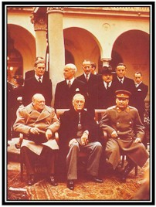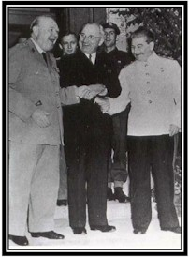
1) _______________ _______________ 1) _______________ _______________
2) _______________ _______________ 2) _______________ _______________
3) _______________ _______________ 3) _______________ _______________

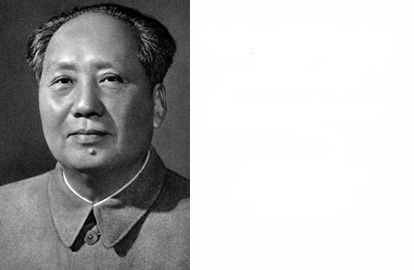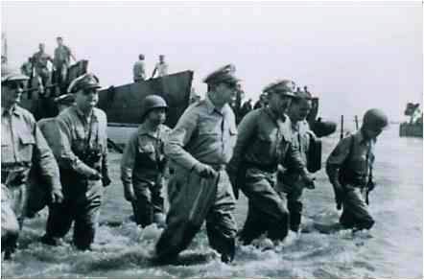

4) _______________ 5) _______________
_______________ _______________

