AL ITTIHAD PRIVATE SCHOOL – AL MAMZAR

History Term II Test
Grade 12 Time: 90 minutes
Marks: 60

- Fill in the missing words. Some might come from the box below. (10)
Mao Tse Tong Chaing Kai Shek Taiwan
People’s Republic of China Batista Fidel Castro
Che Guevara John F Kennedy Nikita Krushev Ho Chi Minh

  - The Communists in China were led by _____________________.
  - The Nationalists in China were led by _____________________.
  - The communist China is called _____________________.
  - The capitalist China is called The Republic of China or _______________.
  - In Cuba, _______________ and _______________ overthrew the US backed dictator _______________.
  - _______________ funded and supported Cuban exiles in an attack of Cuba at the Bay of Pigs.
  - The soviet leader _______________ decided to place nuclear missiles on Cuba.
  - Communist forces in Vietnam were led by the veteran soldier _______________.

- Study the map of China and read Mao’s statement. (20)

  - On the map, label the communist areas AND the nationalist areas. (2)
  - On the map, label the route of the Chairman Mao’s Long March. (1)
  - How was the Long March a disaster for Mao? (2)
__________________________________________________________________
__________________________________________________________________
  - How was the Long March a success for Mao? (2)
__________________________________________________________________
__________________________________________________________________
  - Why do you think it was important for Mao to get the support of the Chinese peasants? (2)
__________________________________________________________________
__________________________________________________________________
  - Do you think Mao’s statement gives a reliable account of the Long March? (1)
__________________________________________________________________
  - How did the two superpowers (USA and USSR) take sides with the two Chinas? (2)
USSR : _____________________________________________________________
USA : ______________________________________________________________
  - Which countries did China invade to expand its power (3)
    - _________________________
    - _________________________
    - _________________________
  - What happened during the Cultural Revolution and how long did it last for? (5)
__________________________________________________________________
__________________________________________________________________
__________________________________________________________________
__________________________________________________________________
__________________________________________________________________
__________________________________________________________________
__________________________________________________________________

- Study the following map in order to answer the questions which follow each.(15)

  - Fill out the following timeline of events in the Cuban Missile Crisis. (8)

- Fidel Castro and Che Guevara overthrow _________________________
- ______________________helps Cuban exiles to invade the Bay of Pigs.
- The invasion fails badly.
- USSR sends ________________________________________ to Cuba.
- President Kennedy warns the USSR that ________________________
__________________________________________________________
- The USSR promises the UN that there will be no ____________________
- 20 Soviet ships are on their way _________________________________
- President Kennedy gives the order to _____________________________
- The Soviet ships _____________________________________________
- Everyone breathes a sigh of relief.

  - Explain any 2 options Kennedy had to face when he learned there were more missiles on their way to Cuba. Why did he (or didn’t he) take these options. (4)
__________________________________________________________________
__________________________________________________________________
__________________________________________________________________
__________________________________________________________________
__________________________________________________________________
__________________________________________________________________
  - What was the result (importance) of the Cuban Missile Crisis for world history? (3)
- ________________________________________________________________
- ________________________________________________________________
- ________________________________________________________________

- Study the Vietcong poster and US Army photograph in order to answer the questions which follow each. (15)

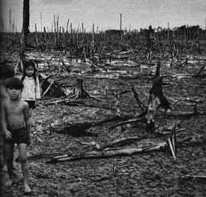

  - Why was the poster created? What is its message? (1)
__________________________________________________________________
  - Why was the photograph taken? What is the message for a war supporter? (2)
__________________________________________________________________
__________________________________________________________________
  - What is the message for a war critic? (2)
__________________________________________________________________
__________________________________________________________________
  - Use the following table to compare and contrast US and Vietcong approaches in Vietnam. (5)

 | US Army | Vietcong
Objectives
Supply of weapons
Source of Soldiers
Treatment of Vietnamese civilians
Field Tactics

- Name the following Cold War personalities. (3)
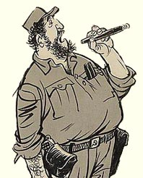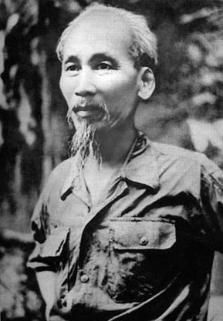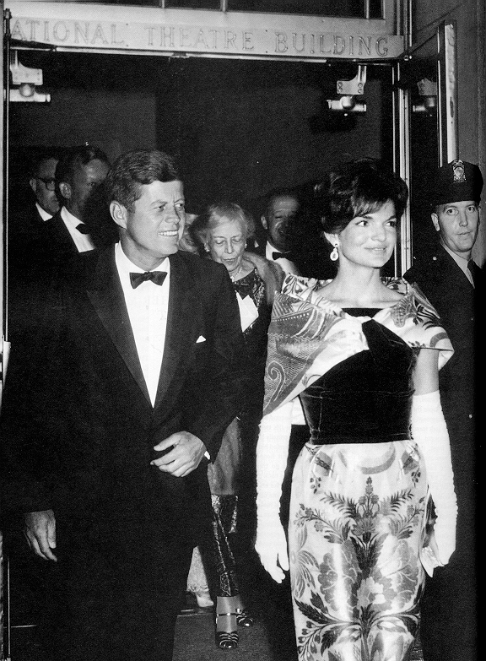

__________________ __________________ _________________

- Identify these famous Cold War Images. (2)

A. 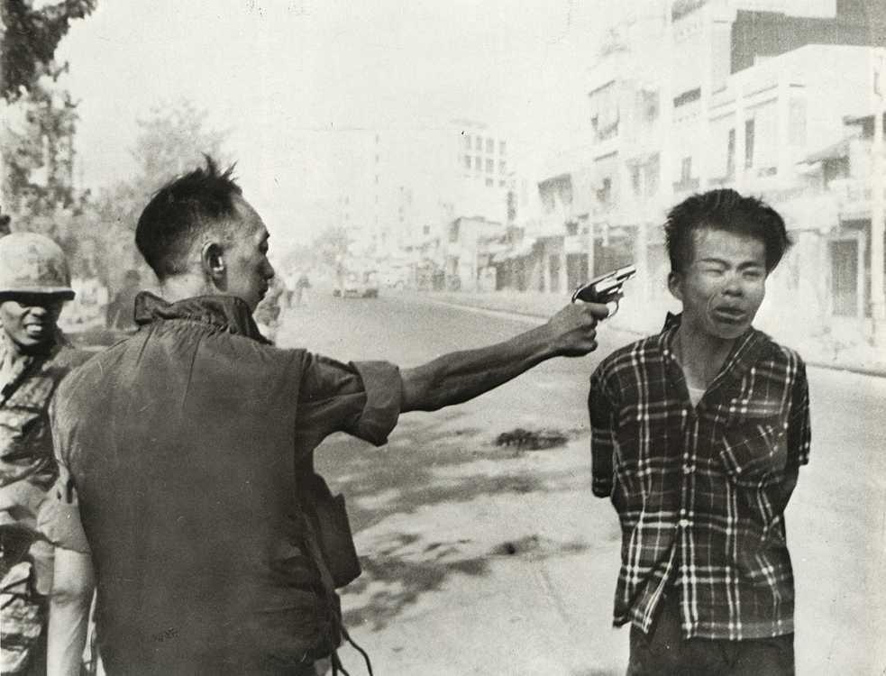 B. 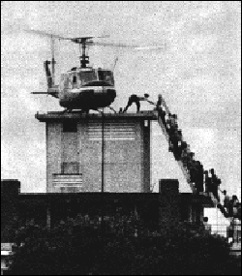
A. __________________________________________________________________
__________________________________________________________________
B. __________________________________________________________________
__________________________________________________________________

