AL ITTIHAD PRIVATE SCHOOL – AL MAMZAR

History Term III Test
Grade 12 Time: 90 minutes
Marks: 60

- Fill in the missing words. Some might come from the box below. (10)
Ayatollah Khomeini Ronald Reagan Lech Walesa Mikhail Gorbachev Boris Yeltsin Star Wars
détente Glasnost Berlin Wall Perestroika

  - In the 1970s, there was a thaw in the Cold War called a period of _______________, or friendliness.
  - In the 1980s, the US president _______________ hated communists and his policies renewed the Cold War.
  - In Persia/Iran, the _______________ led an Islamic revolution to replace the pro-western Shah.
  - Ronald Reagan was responsible for developing a missile defence system called SDI, or “_______________”.
  - The Russian president, _______________, was awarded the Nobel Peace prize with Ronald Reagan for his efforts to end the cold war.
  - A polish auto-electrician, _______________, was also awarded the Nobel peace prize for his efforts to help the people of Poland.
  - The clearest sign that the Cold War was over occurred in Germany with the destruction of the _______________.
  - Gorbachev’s policies of _______________ and _______________ led to a revolution in the USSR.
  - The Russian president _______________ introduced a free-market economy and capitalism into Russia.

- Study the photograph of Lech Walesa taken in Poland in 1990. (10)

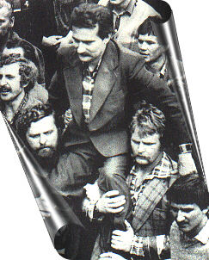

  - What was the name of Walesa’s political party? (2)
________________________________
  - What were the people in this party trying to get the Polish government to do? (2)
___________________________________________________________________
___________________________________________________________________
  - What happened to Walesa because of his party’s protests and strikes? (2)
___________________________________________________________________
___________________________________________________________________
  - In prison, Walesa was given the (circle one) (1)
Pulitzer Prize Nobel Peace Prize Electric shock torture
  - Briefly explain what happened to Walesa after his release from prison. (3)
___________________________________________________________________
___________________________________________________________________

- Study the letter from Italian children to Mikhail Gorbachev &Ronald Reagan.(10)
Dear Gorbachev and Reagan,
We are nine-year old Italian children, pupils at the Pero elementary school in the province of Milan.
We saw on television and read in the papers about your meeting, during which you came to an important decision: to begin to destroy a small part of your nuclear weapons. We want you to know that we all heaved sigh of relief, because we think that all the weapons are dangerous, useless, damaging and producers of violence, death, fear and destruction and that their only purpose is to do evil.
We want you to know that we are happy about your initiative, but we also want to tell you that is not enough. For there to be true peace all arms must be destroyed.
Children from Pero (Milan), Italy, 16 December, 1987

  - Describe how Mikhail Gorbachev lost control of the USSR and how it split up. (4)
___________________________________________________________________
___________________________________________________________________
___________________________________________________________________
___________________________________________________________________
___________________________________________________________________
___________________________________________________________________
___________________________________________________________________
  - Explain how Ronald Reagan hated the communists and what he did to defeat them. (4)
___________________________________________________________________
___________________________________________________________________
___________________________________________________________________
___________________________________________________________________
___________________________________________________________________
___________________________________________________________________
  - How were these two leaders rewarded in 1990 by the rest of the world for their efforts to bring peace and prosperity? (2)
___________________________________________________________________

- Study the Time Magazine cover of Col. Oliver North. (10)
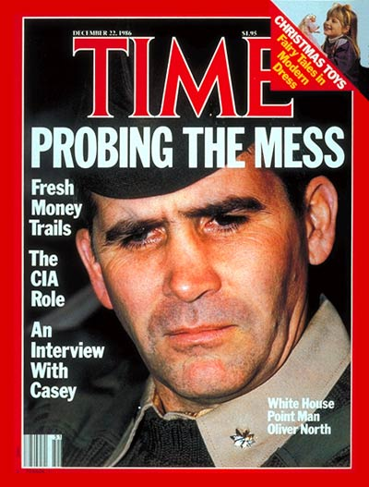

  - Write a short paragraph about the Iran Contra (“Irangate”) affair. Use the following questions as guidelines. What “money trails” is the magazine referring to? Where did the money come from? Who was it sent to? Why was it sent to them? How was Col. Oliver North involved in the “mess” or “money trail”? Which US president took responsibility for this? Why did the president have to do all of this secretly?
___________________________________________________________________
___________________________________________________________________
___________________________________________________________________
___________________________________________________________________
___________________________________________________________________
___________________________________________________________________
___________________________________________________________________
___________________________________________________________________
___________________________________________________________________
__________________________________________________________________
___________________________________________________________________
___________________________________________________________________
___________________________________________________________________
___________________________________________________________________
___________________________________________________________________

- Name the following leaders and the country they led. (10)

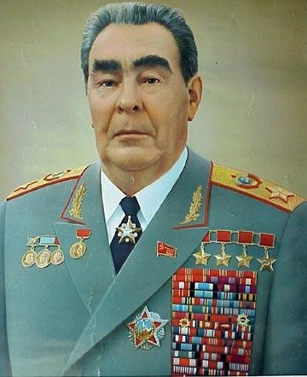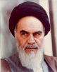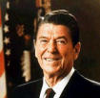
_______________ _______________ _______________
_______________ _______________ _______________

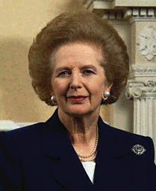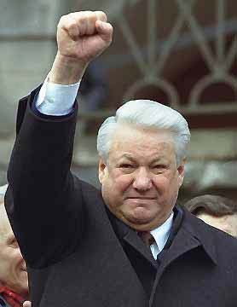

_______________ _______________
_______________ _______________

- Study the following video grab of the fall of the Berlin Wall. (10)

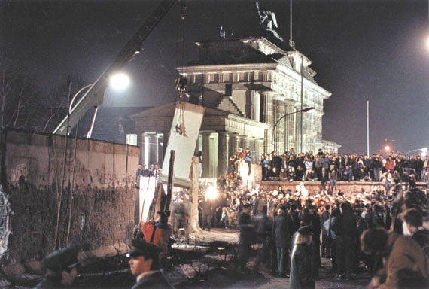

Arrange the following events on the timeline below.

- Gorbachev orders Honecker (E.Germany) to reform.
- Berlin Wall guards join the demonstrators.
- Demonstrators break down the wall.
- Enormous demonstrations in E. Germany against Erich Honecker.
- East Germans march to the Berlin Wall.
- Honecker orders soldiers to fire on the demonstrators.
- Soldiers refuse to obey the orders.

