AL ITTIHAD PRIVATE SCHOOL – AL MAMZAR

History Term IV Test
Grade 12 Time: 90 minutes
Marks: 60

- Fill in the missing words. Some might come from the box below. (10)
Developed nations Developing nations Multi-national corporations
Free trade global economy
Shock Therapy ethnic cleansing Deng Xiaoping
Four Modernisations Global Warming
Richard Nixon Marshall Tito Perestroika

  - The loose federation of states that used to be called the USSR is now called the ______________________________.
  - Yeltsin attempted a policy of _____________________________ to introduce capitalism into the Russia.
  - The policy of _____________________________ in Bosnia was similar to nazi race policies of WWII.
  - _____________________________ took over from Zhou Enlai and Mao Tse Tung as leader of China in 1976.
  - Deng’s policy of _____________________________ called for progress in 4 economic areas.
  - Heavily industrialised nations are now called _____________________________.
  - Some _____________________________ are richer and more powerful than some _____________________________.
  - _____________________________ is essential in a _____________________________.

- Study the maps and then answer the questions which follow each. (15)
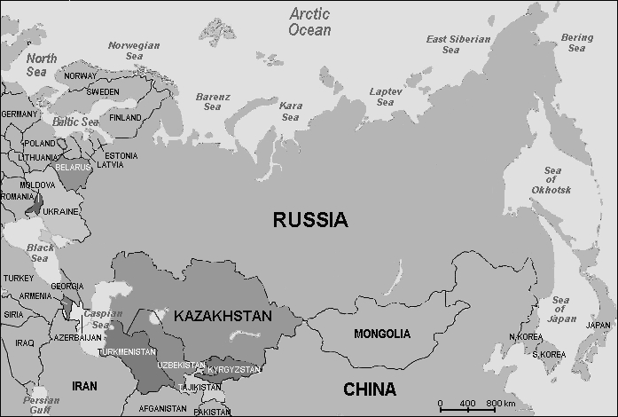
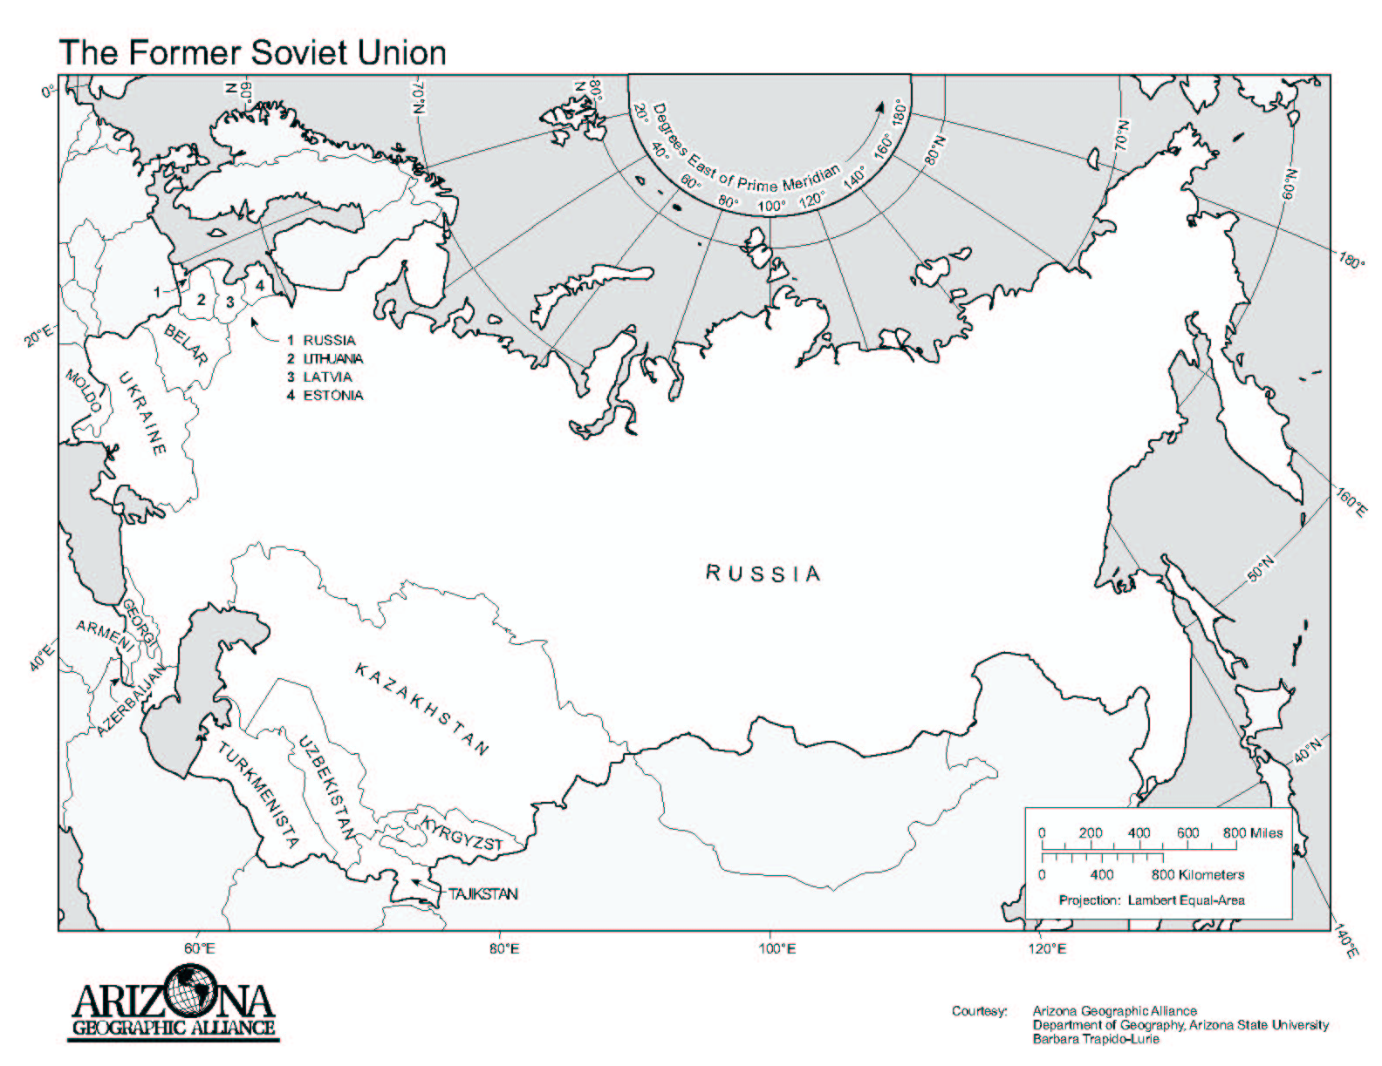

  - How have the boundaries of the second map changed? (2)
___________________________________________________________________
___________________________________________________________________
  - Which Russian leader who announced the break-up of the territory in Map 1? (1)
___________________________________________________________________
  - What 2 events helped lead to the break-up of this area? (4)
___________________________________________________________________
___________________________________________________________________
___________________________________________________________________
  - Who was the popular new president who introduced pure capitalism into Russia? (1)
___________________________________________________________________
  - What problems did he face in changing Russia? (2)
___________________________________________________________________
___________________________________________________________________
___________________________________________________________________

- Study the cartoon and then answer the questions which follow. (7)
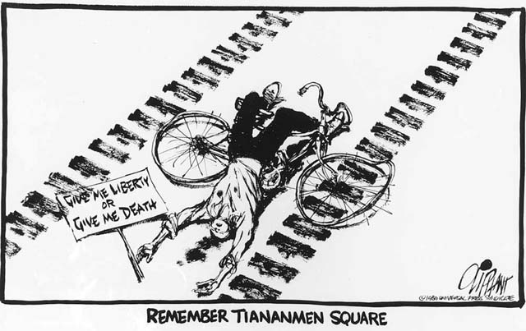
  - What happened in China that caused the cartoonist to draw this cartoon? (3)
___________________________________________________________________
___________________________________________________________________
___________________________________________________________________
___________________________________________________________________
  - What is the cartoonist’s opinion of the events in 1989? (2)
___________________________________________________________________
___________________________________________________________________
  - Is he justified in his opinion? (Does he have a good reason for this opinion?) Explain. (2)
___________________________________________________________________
___________________________________________________________________
___________________________________________________________________

- Study the photographs and then answer the questions which follow each. (15)

  - What wall are the people dismantling? (1)
___________________________________________________________________
  - What did this wall symbolise to the West Europeans and also to the East Europeans?
(2)
___________________________________________________________________
__________________________________________________________________
___________________________________________________________________
  - How was the Eastern side of the wall different to the western side? (2)
___________________________________________________________________
___________________________________________________________________

  - What’s the name of the last British governor of Hong Kong seen here receiving the flag from his guard? (1)
___________________________________________________________________
  - Why is he receiving the flag for the last time? (2)
___________________________________________________________________
___________________________________________________________________
  - Why was he worried about the future of Hong Kong’s residents? (2)
___________________________________________________________________
___________________________________________________________________
___________________________________________________________________

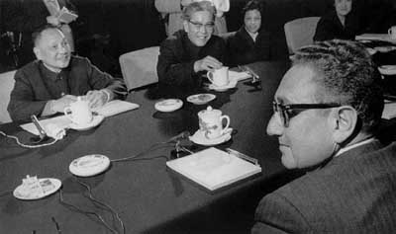

  - Who are the two main delegates (facing each other) and which countries do they represent? (4)
___________________________________________________________________
___________________________________________________________________
  - How did Deng Xiaoping try to reform China after Mao’s failures. (3)
___________________________________________________________________
___________________________________________________________________
___________________________________________________________________
___________________________________________________________________

- Diagrams. Complete the diagram on the causes and effects of post-cold war Economic Development. (6)

CAUSES EFFECTS
Post
Cold War Economic Development

