AL ITTIHAD PRIVATE SCHOOL – AL MAMZAR

History Term IV Test
Grade 12 Time: 90 minutes
Marks: 60

Answer any SIX sections

Marks will be deducted if you answer more than six!

- Fill in the missing words. Some might come from the box below. (10)
Mao Tse Tung Chiang Kai Shek People’s Republic of China Taiwan Deng Xiaopeng Developed Nations Developing Nations Weapons of Mass Destruction IRA ETA November 17 Red Brigade materialism

  - In 1949 _____________________________ left mainland China to create the capitalist Republic of China, also called _____________________________ .
  - _____________________________ remained in China to create the _____________________________ which became communist.
  - After Mao died, the next Chinese premier _____________________________ introduced four modernisations in China to improve the conditions of workers.
  - Heavily industrialised nations are now called _____________________________.
  - Some examples of European terrorist groups famous in the 1970s and 1980s are _____________________________, _____________________________, and _____________________________ .
  - _____________________________ is when people place too much value on owning things, especially luxury goods.

- Study the following two pictures as a guide to answering the questions that follow. (10)
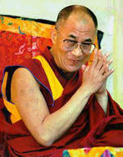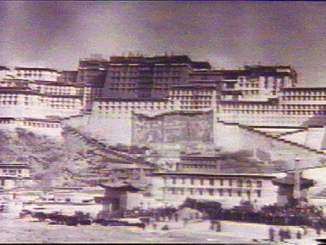

  - Who is the person shown in the picture and what position does he hold? (3)
___________________________________________________________________
___________________________________________________________________
  - Why does the Chinese government prefer not to have any dealings with him? (2)
___________________________________________________________________
___________________________________________________________________
  - What is the name of the Palace shown above? (2)
___________________________________________________________________
  - What happened in Tibet to cause friction between the Chinese and Tibetans. (3)
___________________________________________________________________
___________________________________________________________________
___________________________________________________________________

- Study the following video grab and map of Hong Kong as a guide to answering the questions which follow. (10)
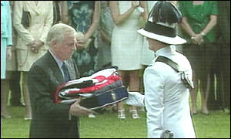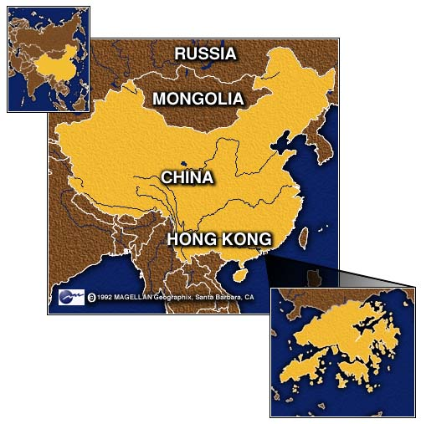
  - How did Britain come to control part of China? What other only colonial power also controlled part of china? (2)
___________________________________________________________________
___________________________________________________________________
___________________________________________________________________
  - Why is Patten receiving the flag for the last time? (2)
___________________________________________________________________
___________________________________________________________________
  - How did he try to help the residents of Hong Kong? (2)
___________________________________________________________________
___________________________________________________________________
  - Did he succeed in helping them? (2)
___________________________________________________________________
___________________________________________________________________
  - What happened to the Honk Kong Chinese after the 1997 handover? (2)
___________________________________________________________________
___________________________________________________________________

- Study the cartoon and then answer the questions which follow. (10)
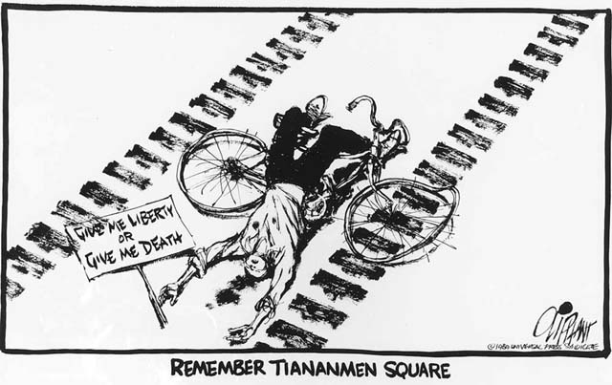
  - What happened in China that caused the cartoonist to draw this cartoon? (6)
___________________________________________________________________
___________________________________________________________________
___________________________________________________________________
___________________________________________________________________
  - What is the cartoonist’s opinion of the events in 1989? (2)
___________________________________________________________________
___________________________________________________________________
  - Is he justified (have a good reason) in his opinion? Explain. (2)
___________________________________________________________________
___________________________________________________________________
___________________________________________________________________

- Economic Development. (10)

  - Complete the following diagram on Global Economic Development (6)

CAUSES EFFECTS
Post
Cold War Economic Development

  - Explain how environmental affairs (like Oil Wars, Pollution, Global Warming) can seriously affect economic development. (4)
___________________________________________________________________
___________________________________________________________________
___________________________________________________________________
___________________________________________________________________
___________________________________________________________________

- Global Cultures. Study the two pictures as a guide to answering the questions that follow. (10)
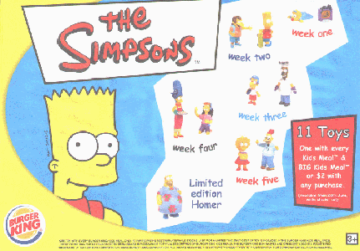

  - Name at least three elements of pop culture found in these images. (3)
___________________________________________________________________
___________________________________________________________________
___________________________________________________________________
  - What communications media are responsible for blending these images into our cultures? (3)
___________________________________________________________________
___________________________________________________________________
___________________________________________________________________
  - Describe how people you know have responded to cultural blending: accommodation, restriction, or revivalism? Give examples from your own experience. (4)
___________________________________________________________________
___________________________________________________________________
___________________________________________________________________
___________________________________________________________________
___________________________________________________________________

- Global Security. Study the extract from the Universal Declaration of Human Rights. (10)

Article 1.
All human beings are born free and equal in dignity and rights.They are endowed with reason and conscience and should act towards one another in a spirit of brotherhood.

Article 2.
Everyone is entitled to all the rights and freedoms set forth in this Declaration, without distinction of any kind, such as race, colour, sex, language, religion, political or other opinion, national or social origin, property, birth or other status. Furthermore, no distinction shall be made on the basis of the political, jurisdictional or international status of the country or territory to which a person belongs, whether it be independent, trust, non-self-governing or under any other limitation of sovereignty.

Article 3.
Everyone has the right to life, liberty and security of person.

Article 4.
No one shall be held in slavery or servitude; slavery and the slave trade shall be prohibited in all their forms.
  - How has the Charter of Human Rights helped Global security? (2)
___________________________________________________________________
___________________________________________________________________
  - Name three other attempts at keeping the world secure. (3)
___________________________________________________________________
___________________________________________________________________
___________________________________________________________________
  - What are terrorist groups and how do they threaten global security? (2)
___________________________________________________________________
___________________________________________________________________
  - How can this Declaration help prevent ethnic conflicts? (3)
___________________________________________________________________
___________________________________________________________________
___________________________________________________________________

